
Sreenidhi Institute of Science and Technology
H.T No
Regulations:
A20
(An Autonomous Institution)
Code No: 8K293 Date: 20-Sept-2021 (FN)

B.Tech I-Year II- Semester External Examination, September - 2021 (Regular)
COMPREHENSIVE VIVA TEST - II (CIVIL)

Time: 3:00 Hours Max.Marks:70
Note: Answer Any 70 Questions.
Student can solve more than 70 questions, but maximum 70 marks will be awarded.
Calculator's are not allowed.

S.No | Question
1. | The second order P.D.E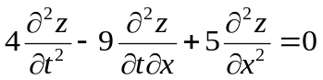is ₋₋₋₋₋₋₋₋₋₋₋₋₋₋₋₋  a) elliptic b)parabolic c)hyperbolic d)none of these
2. | Solve 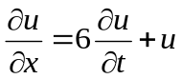using the method of separation of variables if u(x,0) = 10 e^{-x}.  a) 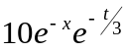 b)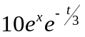 c)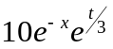 d)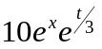
3. | While solving a partial differential equation using a variable separable method, we equate the ratio to a constant which?  a) can be positive or negative integer or zero b) can be positive or negative rational number or zero  c) must be a positive integer d) must be a negative integer
4. | If double integral in Cartesian coordinate is given by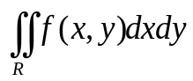then the value of same integral in polar form is _____  a) 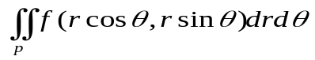 b)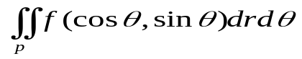  c)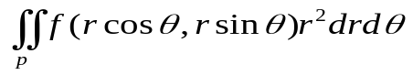 d)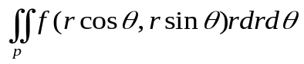
5. | Evaluate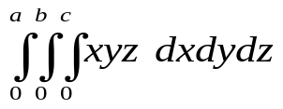  a) 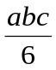 b) 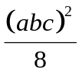 c) 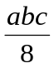 d) 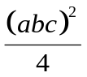
6. | The volume of ellipsoid 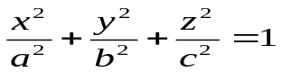is  a) 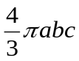cubic units b) 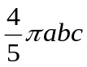cubic units c) 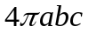cubic units d) 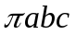cubic units
7. | The Green’s theorem can be related to which of the following theorems mathematically?  a) Gauss divergence theorem b) Stoke’s theorem c) Leibnitz’s theorem d) none of these
8. | The Gauss divergence theorem converts  a) line to surface integral b) surface to line integral  c) line to volume integral d) surface to volume integral
9. | The Stoke’s theorem uses which of the following operation  a) Divergence b) Gradient c) Curl d) Laplacian
10. | Find the Order and Degree of the equation 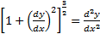  a) 2,3/2 b) 2,2c) 2,3d) 1,1
11. | By the elimination of constants A and B ,find the differential equation of  a) b) c) d)
12. | If , and are three different roots of AE of a Differential equation then is  a) b)  c) d)
13. | 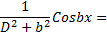  a) b) c) d)
14. | PDE of Z= f(  a) py-qx=0 b) py+qx=0 c) z=py-qx d) z= py+qx
15. | Solution of p= q²  a) z=b+by+c b)z= bx-b c)z=b²x+by+c d)None of the above
16. | The Differential equation 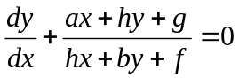 is  a) Homogeneous b) Variables Separable c) Exact d)None of them
17. | The general solution of 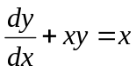is  a) 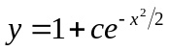 b) 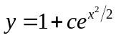 c) 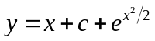 d) None
18. | Integrating factor of 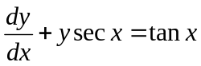is  a) secx + tanx b)secx- tanx c) sec²x d) None of them
19. | The general solution of (D³ – 3D² + 3D -1)y = 0 is  a) (c₁ + c₂x + c₃x²)e^{x} b) (c₁ + c₂x + c₃x²)e^{-x} c) c₁e^{x} + c₂e^{2x} + c₃e^{3x} d) None
20. | The Complementary function of (D³ - D)y = x is  a) c₁ + c₂x + c₃e^{x} b) c₁ + c₂e^{x} + c₃e^{-x} c) (c₁ + c₂x)e^{x} + c₃e^{-x} d) None
21. | 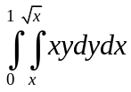  a) 1/8 b) 1/16 c) 1/24 d) none
22. | 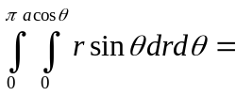  a) a²/2 b) a²/3 c) a³/3 d) a³/4
23. | In Polar coordinates, 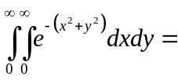  a) 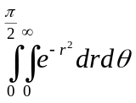 b) 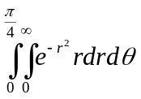 c) 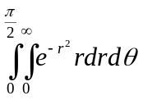 d) 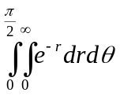
24. | The solution of the equation 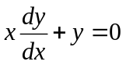passing through (1, 1) is  a) x = y b) xy = 1 c) y = 1 d) x =1
25. | The general solution of 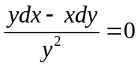 is  a) xy = c b) y = cx c) x = cy² d) x = cy
26. | Which crystals is having the lattice parameters, a = b ≠ c; α = β = ү = 90⁰?  a) Cubic b) Monoclinic c) Tetragonal d) Triclinic
27. | A crystal is held together entirely by  a) Gravitational force b) Electrostatic force c) Magnetic force d) Nuclear force
28. | (2 2 2) and (1 1 1) planes in a cubic crystal  a) are perpendicular to each other b) are parallel to each other  c) intersect at angle 57⁰ d) intersect at angle 30⁰
29. | In a simple cubic lattice d₁₀₀ : d₁₁₀ : d₁₁₁ is  a) 6 : 3 : 2 b) 6 : 3 : √2 c) √6 : √3 : √2 d) √6 : √3 : √4a)
30. | The effective number of sodium ions per unit cell of N_{a}Cl is  a) 2 b) 4 c) 6 d) 8
31. | Burgers vector defines  a) the magnitude of point defect b) the orientation of different crystal plausesvectrially  c) the magnitude and the direction of dislocation. d) None of these
32. | X-rays diffraction intensities depend upon  a) The electrons of inner most shell of the atom b) Electrons of outermost shell of the atom  c) Scattering from nuclei any electron shell of the atom d) Any electron shell of the atom
33. | A dislocation is  a) always under shear b) a one dimensional defect  c) a two dimensional defect d) both (a) & (b)
34. | In powder method, incident χ - rays reflected back when the incident angle θ =  a) 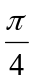 b) 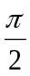 c) 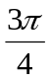 d) π
35. | Monochromatic χ - rays are used in  a) Bragg’s spectrometer b) lave method c) Powder method d) all the above
36. | The amplitude of free vibration  a) Decreases with time b) Remains constant  c) Increases with time d) Rises to a maximum and then decreases with time
37. | The effect of increasing tension by 4 times and reducing length to half on the fundamental frequency of a stretched string is  a) Decreasing frequency by 4 times b) Increasing frequency by 4 times  c) Doubling the frequency d) Halving the frequency
38. | Magnetostriction means  a) Change of magnetism b) Change of length  c) change of length with magnetic field d) Change of magnetic poles
39. | This is an example of resonance  a) Vibrations of a tuning fork excited with a rubber hammer  b) Oscillations of a simple pendulum in oil  c) Vibrations of air column in volume resonance bottle with maximum loudness  d) Vibrations of a plucked string
40. | The phase difference at amplitude resonance is  a) Less than п/2 radians b) Equal to п/2 radians  c) Greater than п/2 radians d) Greater than 3п/2 radians
41. | Formation of interference fringes is in accordance with  (a) Law of conservation of momentum (b) Constant amplitude  (c) Law of conservation of energy (d) none of these
42. | When a light wave reflected at the surface of an optically denser medium, it suffers a phase change of  (a) π/2 (b) 2π (c) π (d) π/4
43. | The tip of a needle does not give a sharp image on the screen. This is due to  (a) Interference (b) diffraction (c) polarization (d) refraction
44. | By reducing the size of metal particles from bulk to nano, the energy bands are  (a) narrower (b) remains same (c) wider (d) none of the above
45. | The different types of single wall carbon nanotubes are  (a) arm chair (b) zig-zag (c) chiral type (d) all of the above
46. | The surface area to volume ratio for nanoparticles is  (a) moderate (b) very less (c) very large (d) none of the above
47. | The gas lasers give _______ coherent beam compare to semiconductor laser  (a) less (b) equal (c) more (d) none
48. | The main source of sun energy  (a) Nuclear fusion (b) Nuclear fission (c) Gravitational contraction (d) Combustion
49. | Nanostructures have sizes in between  (a) 1 – 100 A⁰ (b) 1 – 100 nm (c) 100 – 1000 nm (d) None of these
50. | In excited states, the atoms will remain for a time of  (a) 10⁸ s (b) 10⁻⁸ s (c) 10⁻³ s (d) 10⁻⁵ s
51. | If you look at all the headlines in a paper, what are you doing?  a) skimming b) scanning
52. | What sort of reading do you use to find out what's on TV today?  a) skimming b) scanning c) careful reading.
53. | Comprehension skills that measure the ability of a reader to interpret what she has read is...  a) Interpretive b) Literal c) Applied d) Appreciative
54. | The reader makes links between the text and his or her own experience and knowledge to develop an answer is  a) Interpretive b) Literal c) Applied d)Appreciative
55. | What is the expanded form of SQ3R as a reading skill?  a) Supervise, quote, read, recite, review b) Survey, question ,read , recite , review  c) survey ,question, read , remote , recall d) Service , question , right , recite, review
56. | ________ is another term for junk email.  a) Attachment b) Spam c) Bcc d) Malware
57. | Complete the following statement: A well‐written paragraph should ________  a) Focus on a single, coherent idea. b) Consist of logically connected sentences.  c) Both a and b d) None of the above
58. | A kind of letter that the formal way of communicating between two or more parties. This letters can be informational, persuasive, motivational, or promotional.  a) Business letter b) Complaint letter c) Request letter d) Relieving letter
59. | Modern business letters are usually written in:  a) simplified style b) semi-block style c) indented style d) block style
60. | Usage of all capital letters in email is considered as  a) Showing importance b) Looks fancy c) Screaming/Insulting d) Irrelevant
61. | If he does not improve his behavior, he will lose all his friends. This sentence is ______  a) Simple Sentence b) Compound Sentence c) Complex sentence d) Compound complex sentence
62. | Which sentence is correct?  a) My wedding ring is a bit lose.I need to get it altered.  b) My wedding ring is a bit loose.I need to get it altered.
63. | Which sentence is written correctly?  a) Their great pictures of our trip. b) How did you ever get it's picture?  c) My sister says they're very shy d) You're sister is right.
64. | The king died ______  a) hareless b) heirless c) hairless d) airless
65. | Select the word that is closer in meaning to the following word. Weary  a) Tired b) Fatigued c) Sentimental d) Emotional
66. | If the area of a section is in mm2 and the distance of the centre of area from a line is in mm, then units of the moment of inertia of the section about the line is expressed in  (a) mm² (b) mm³ (c) mm⁴ (d) mm⁵
67. | Theorem of perpendicular axis is used in obtaining the moment of inertia of a  (a) triangular lamina (b) square lamina (c) circular lamina (d) semi-circular lamina
68. | The moment of inertia of a circular section of diameter (d) is given by the relation  (a) π/16 (d )⁴ (b) π/32 (d )⁴ (c) π/64 (d )⁴ (d ) π/96 (d )⁴
69. | The moment of inertia of a triangular section of base (b) and height (h) about an axis through its c.g. and parallel to the base is given by the relation.  (a) bh³ / 12 (b) bh³ / 24 (c) bh³ / 36 (d) bh³ / 48
70. | The moment of inertia of a triangular section of base (b) and height (h) about an axis passing through its vertex and parallel to the base is ... as that passing through its C.G. and parallel to the base.  (a) twelve times (b) nine times (c) six times (d) four times
71. | The relationship S = ut + ½ at² is applicable to bodies  (a) moving with any type of motion (b) moving with uniform velocity  (c) moving with uniform acceleration (d) both (b) and (c)
72. | The motion under gravity is a particular case of motion under constant velocity.  (a) Yes (b) No
73. | If two bodies A and B are projected upwards such that the velocity of A is double the velocity of B, then the height to which the body A will rise will be.......... the height to which the body B will rise  (a) two times (b) four times (c) eight times
74. | A lecturer told the class that if a body is projected upwards from any point, then the body while coming down at the same point will have the same velocity with which it was projected upwards. Is his statement correct?  (a) Agree (b) Disagree
75. | We are given an equation of displacement (s) in terms of time (t). If we differentiate it with respect to t, the equation so obtained will give  (a) velocity (b) acceleration (c) distance traversed
76. | The second differentiation, of the above equation will give  (a) velocity (b) acceleration (c) distance traversed
77. | If we differentiate an equation in terms of acceleration and time, it will give  (a) velocity (b) distance traversed (c) none of these two
78. | We are given an equation of acceleration  (a) in terms of time (t). The second integration of the equation will give the velocity. (a) Yes (b) No
79. | Which of the following statement is wrong?  (a) A body falling freely under the force of gravity is an example of motion under variable acceleration. (b) A bus going down the valley may have variable acceleration.  (c) A lift going down in a gold mine cannot have constant acceleration in the entire journey.  (d) In a cricket match, the ball does not move with constant acceleration.
80. | The relative velocity of A with respect to B is the velocity with which A appears to move to an observer sitting in B when it is  (a) at rest (b) in motion (c) either (a) or ( b)
81. | The rain is falling vertically downwards, but it appears to fall at some angle to a man walking along a road. If the man increases his speed, the inclination of the rain with the vertical will  (a) increase (b) remain the same (c) decrease
82. | The relative velocity of two bodies moving along inclined directions is found out by superimposing the actual velocities of both the bodies.  (a) Agree (b) Disagree
83. | When the two ships are moving along inclined directions, then the time when the two ships will be closest together depends upon  (a) velocity of one of the ships (b) velocity of both the ships  (c) angle between the two directions (d) all of the above
84. | The horizontal range of a projectile is maximum when the angle of projectile is  (a) 30° (b) 45° (c) 60° (d) 75°
85. | The maximum height of a projectile on a horizontal range is  (a) u²sin2α/ 2g (b) u²sinα/ 2g (c) u²sin²2α/ 2g (d) u²sin²α/ 2g
86. | In the ________ traversal we process all of a vertex’s descendants before we move to an adjacent vertex  a) Depth First b) Breath First c) With First d) Depth Limited
87. | The property of binary tree is  a) The first subset is called left subtree b) The second subtree is called right subtree  c) The root cannot contain NULL d) The right subtree can be empty
88. | If the sequence of operations (push(1), push(2), pop, push(1), push(2), pop, pop, pop, push(2), pop), are performed on a stack, the sequence of popped out values are _____.  (a) 2, 2, 1, 1, 2 (b) 2, 2, 1, 2, 2 (c) 2, 1, 2, 2, 1 (d) 2, 1, 2, 2, 2
89. | Which of the following data structures is linear type?  a) Graph b) Tre c) Binary Tree d) Stack
90. | The way in which the data items are logically related defined  a) Storage structures b) data structures c) data relationship d) data operation
91. | Minimum number of fields in each node of a doubly linked list is ____  a) 2 b) 3 c) 4 d) None of the above
92. | A linear list in which each node has pointers to point to the predecessor and successors nodes is called as…  a) Singly linked List b) Circular Linked List c) Doubly Linked List d) Linear Linked List
93. | The disadvantage in using a circular linked list is _____  a) It is possible to get into infinite loop b) Last node points to first node  c) Time consuming d) Require more memory space
94. | Apply Quick sort on the given sequence 17, 21, 24, 16, 19, 14, 13, 22. What is the sequence after first phase, pivot is first element.  a. 13, 14, 16, 17, 19, 21, 22, 24 b. 16, 13, 14, 17, 19, 24, 21, 22  c. 14, 13, 16, 17, 24, 19, 22, 21 d. 16, 13, 14, 17, 22, 21, 19, 22
95. | What is the worst case time complexity of heap sort algorithm?  a. O(n²) b. O(n) c. O(n log n) d. O(log n)
96. | Which of the following algorithm is best suited if the elements are already sorted.  Heap Sort b.Quick Sort c. Selection Sort d. Insertion Sort
97. | Which of the following features must be supported by any programming language to become a pure object-oriented programming language?  a. Encapsulation b. Inheritance c. Polymorphism d. All of the above
98. | What is will be the output of the following programs:  #include <iostream>  using namespace std;  class A  {  public:  A()  {  cout<<"Default Constructor called\n";  }  A(int a)  {  cout<<"Perameterized Constructor called\n";  }  };  int main()  {  A a(12);  A b(25);  return 0;  }  a. Default Constructor called b. Default Constructor called  Default Constructor called Parameterized Constructor called  c. Parameterized Constructor called d. Error.  Parameterized Constructor called
99. | Which of the following statement is not true about C++?  a. Members of a class are public by default b. A class cannot have the private members  c. A structure can have the member functions d. All of the above
100. | What will be the output of the following program:  #include <iostream>  using namespace std;  class ABC  {  inta,b;  public:  ABC(inta,int b)  {  this->a=a;  b=b;  }  void display()  {  cout<<endl<<a<<" "<<b;  }  };  int main()  {  ABC ob(25,82);  ob.display();  }  a. 25 82 b. Garbage value Garbage value  c. 25 Garbage value d. Compilation Error

-- 00 -- 00 –

